ARJS library documentation 1.0

In this documentation the main components of the ARJS Library shall be explained, whilst also some components of the ARToolkit5 will be explained.

var ARController = function (width,height,cameraPara):

This function is a function expression which sets all the values of the ARController, from initialized parameters to the width, and the height. It is is called in the init section. The ARController keeps track of the markers we have registered and reads out pixels from the video source. Let's make one using our new-fangled video element.

ARController.prototype.process():

This function tries to read in the markers from the image it is processing currently. It first starts by dispatching a markerNum event, which tells you how many markers have been detected. Next, getMarker is called for each found marker.

The process starts by using this.detectMarker(image). See the detectMarker function for more information. If a marker is found, so the result is equal to 0, we iterate through all marker types, by going through the ARControllers’ patternMarkers, barcodeMarkers, and nftMarkers data structure.

Next, we iterate through each marker found, and get the information. In our case we check for the NFT marker. We store values such as markerInfo, markerType, and etc.

NFT Detection section in ARController.prototype.process():
Go through all found nftMarkers, transform each one of them compared to the camera’s angle.
The ARController.prototype.process() and detectMarker functions are explicitly used by ARJS for Marker detection. However,

ARController.prototype.trackNFTMarkerId():
Adds the given NFT marker ID to the index of tracked IDs. If it already exists then just return the obj.

ARController.prototype.addEventListener():
Add an event listener on the ARController, for the named event. This means that the callback function is called whenever that event is dispatched.

ARController.prototype.loadNFTMarker():
Load the NFT Marker from a given url. If the given url works, the addNFTMarker function is called to add the marker to the recognizable list of NFT markers.

ARController.prototype.detectMarker.image():
A video element is fed, if there is an actual image which can be copied to the heap, we return the artoolkit.detectMarker(this.id) function.
NftMarkerCount is most likely how many loaded NFT’s we got. We then loop through all the ones we loaded and compare it to the marker in the image.

ARController.prototype.transMatToGLMat = function (transMat, glMat, scale)
Converts the given 3x4 marker transformation matrix in the 12-element transMat array into a 4x4 WebGL matrix and writes the result into the 16-element glMat array. If scale parameter is given, scales the transform of the glMat by the scale parameter.

Coordinate system that ARJS uses to transform the NFT marker.
In this implementation a-frames are used to display the NFT-model content. A-frame is an open-source web framework for building virtual reality experiences. It is an entity component system framework for Three.js.

Basic principle of how ARToolkit works, which can also be applied to the theory for ARJS.

The camera captures video of the real world and sends it to the computer.
Software on the computer searches through each video frame for any square shapes.
If a square is found, the software uses some mathematics to calculate the position of the camera relative to the black square.
Once the position of the camera is known a computer graphics model is drawn from that same position.
This model is drawn on top of the video of the real world and so appears stuck on the square marker.
The final output is shown back in the handheld display, so when the user looks through the display they see graphics overlaid on the real world.
For rendering OpenGL is used to process everything.

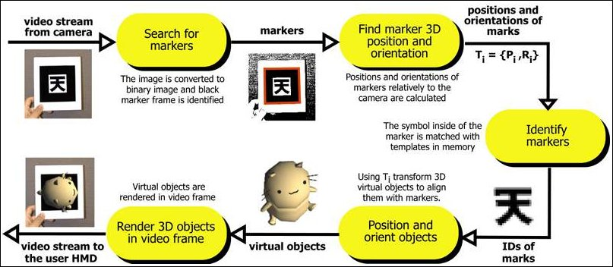

There are two parts to developing applications that use ARToolKit; writing the application, and training image-processing routines on the real world markers that will be used in the application.
Writing an application with ARToolKit is very easy: a simple outline is used for creating an AR application. We base on it for writing a new application. Similarly, training pattern phase is largely simplified with the use of simple tool.

The following steps must be taken in your application main code:
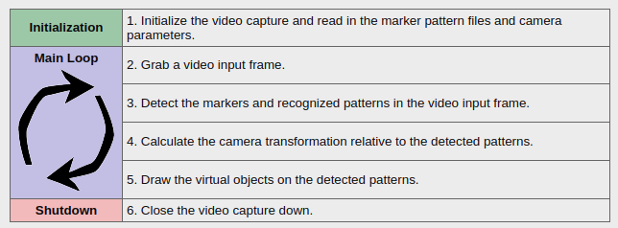
ARToolKit gives the position of the marker in the camera coordinate system, and uses OpenGL matrix system for the position of the virtual object. We will describe more precisely these different elements and their relationship in this tutorial.
Coordinate Systems
We will begin with the simpleTest program. Open it and add this line after arGetTransMat:
printf("%f %f %f\n",patt_trans[0][3],patt_trans[1][3],patt_trans[2][3]);

Recompile and start the program. Look at the output values. If you move the marker to the left, the first value increases, move to the top the second value decreases and move to the front the last value increases also. This is the Coordinate System (CS) used by ARToolKit:

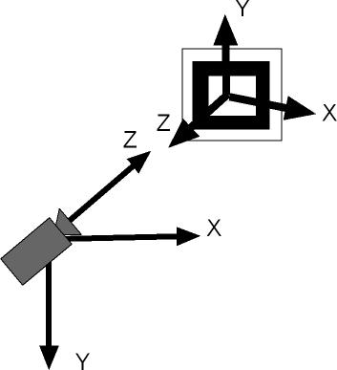

When you pass a canvas to JSARToolKit for analysis, JSARToolKit returns a list of AR markers found in the image and the corresponding transformation matrices. To draw a 3D object on top of a marker, you pass the transformation matrix to whatever 3D rendering library you're using so that your object is transformed using the matrix. Then, draw the video frame in your WebGL scene and draw the object on top of that and you're good to go.

To analyze video using the JSARToolKit, draw the video on a canvas, then pass the canvas to JSARToolKit. Do this for every frame and you've got video AR tracking. JSARToolKit is fast enough on modern JavaScript engines to do this in realtime even on 640x480 video frames. However, the larger the video frame, the longer it takes to process. A good video frame size is 320x240, but if you expect to use small markers or multiple markers, 640x480 is preferable.

ARJS is of a similar procedure. The AR.js framework includes cross-browser compatibility and supports both WebGL and WebRTC, meaning it’s functional across Android and iPhone devices above iOS 11.

WebRTC (Web Real-Time Communication) is a free, open-source project that provides web browsers and mobile applications with real-time communication (RTC) via simple application programming interfaces (APIs). It allows audio and video communication to work inside web pages by allowing direct peer-to-peer communication, eliminating the need to install plugins or download native apps.[3] Supported by Apple, Google, Microsoft, Mozilla, and Opera, WebRTC is being standardized through the World Wide Web Consortium (W3C) and the Internet Engineering Task Force (IETF).[4]

Order of execution example, ARJS.
SetParameters:
parameters will have a sourcetype. Here we check if the sourcetype is equal to webcam. If this is the case, we call initSourceWebcam.
InitSourceWebcam:
we initialize the default values. Video element is created, and attributes are set, such as autoplay, muted, playsinline, etc. Afterwards, out of the function we set more attributes and give it the ID arjs-video.

~~ Lots of boilerplate , setting matrices and stuff ~~

ARJS system is ready
Tracking backend.
Set markerParameters types. In this case to NFT
ARJs.anchor → var camera, var scene, var arContext are set. Also this.parameters.
Get all the available userMedia devices. Get a device which satisfies all of the constraints.

ArController is initialized, which has the cameraParameters that have been set up before the call. A lot of parameters are set, for the canvas and for the video. ARController.prototype is intialized, which sets values such as the framesize, camera_matrix, etc. After prototype intialization, matching colors, detection modes, color_and_matrix, etc are set.

~Potential Resizing~

ARJS-Video loaded event → Resize for alocation video frame size

The most important component of the ARJS library is how the image is read and processed. ARJS creates a worker blob through handleNFT. This worker handles the loading of the NFT markers and the tracking of it. We send the worker a message, called “process” which makes the worker do the processing. This is to increase the performance.

Var msg = e.data (In this case this e.date equals the imageData we get sent.) With as message process. If this is the case we clal the process() function again. NOTE! This process() function is different from the process function found in the non-worker section of a-frame nft. (Meaning that we are not using the process() function in handleNFT again, but another process, which is the ARController.prototype.process function. The parameter ‘next’ in this case is the imageData that we are processing. CopyImageToHeap is called again, indirectly by calling detectMarker in the process function. If the image is copied it means that we will detect the marker. This result is 0, meaning that we are going to continue with the ARController.prototype.process function. The getMarkernum is called, we iterate through all found markers. We check if we found a marker with ID x, which is in the list of markers. If the marker is not found we send a type “not found” Now we are back in aframe-ar-nft non worker js.

We do one more check to see if it was loaded, found, etc. If not, we do not show an object, and we call process() again. This is the process found in handleNFT.

